Transaction States

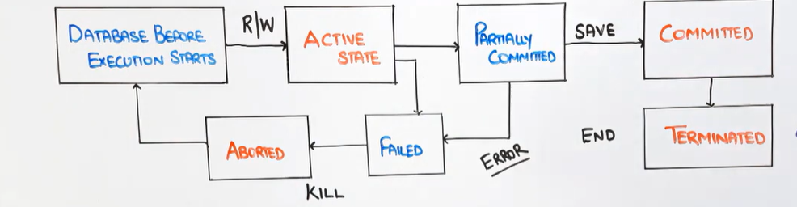

1.Active State

🡪Initial state after execution of db starts. Transaction db is in active state always.

🡪Operations like read write is used

2. Partially Committed

🡪When all the statements are executed but not terminated than stage is called as

Partially Committed.

3. Committed

🡪Save the work or process after execution

4. Failed

🡪If due to any problem the process is stopped half way then kill the process to maintain the atomicity of the database